

Worker’s Compensation User Guide

TABLE OF Contents

Workers Compensation Setup 2

Adding Workers Compensation Policy to Employees 7

Mass Editing Workers Compensation Policy to Multiple Employees 8

E-Comp Report Creation 10

Adding Delivery Destination for E-Comp Report 19

# Workers Compensation Setup

To start, go to Main Menu>Admin>Payroll Setup>Workers Comp>Carriers:

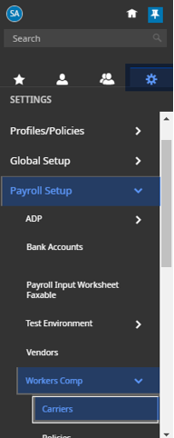

Click on Add Carrier in the upper righthand corner, then add the carrier’s name and click save:

If you have multiple EINs you will receive the following warning, click OK.

Then, you will select add company EIN and select the EINs that pertain to the policy and then click on select, and then click on save, and then add policy.

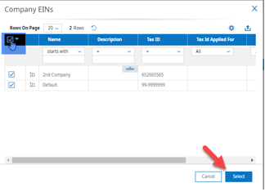

Once you click on add policy you will have to choose the State that the policy relates to and then click OK:

Next, enter in the policy information including policy #, fiscal year start date, and effective start and end dates. **Note, using the infinity date of 12/31/9999 is recommended as an end date as it will allow you to not have to create a new policy prior to ending this policy if applicable.

Next, add in your Earning/Deduction List by clicking on the magnifying glass:

Create a new list, give it a name and click on save, and then add all applicable earning codes, and click on done:

**Note, you will want to make sure to double check with your policy or your client’s policy to determine which earnings to include.

Once complete, click on the flag next to the correct list:

Next, add in a Yearly Wage Limit or 0 for No Limit and then add the company EINs if applicable. Then click save.

Once this has been saved, you will click on add code, select the applicable codes and then click on add selected codes:

**Note that you do not need to add in rates for E-Comp, but you should always double check your policy just in case.

# Adding Workers Compensation Policy to Employees

In order to add the workers compensation policy to the employee, go to Team>My Team>Employee Information

Search for the employee and click on the employee information button.



On the Jump To menu on the Main tab, click on Pay Information and search for the Default Workers Comp Code. Then click on the magnifying glass and select the Workers Comp Code from the options listed:

Once you are back on the Main tab, click save.

# Mass Editing Workers Compensation Policy to Multiple Employees

If several employees all should be assigned to the same Workers Compensation Policy, you can assign that by going to Admin>Mass Edit>Mass Edit Profiles:

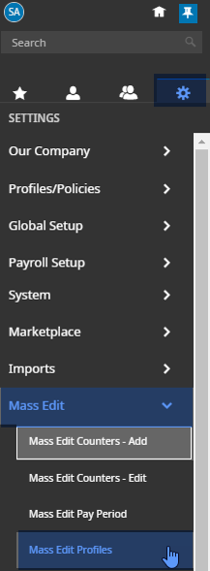

Select the employees you wish to add to the policy and click on mass edit:

Go to the Pay Information section and select the Default Workers Comp Code from the drop-down menu and select apply change.

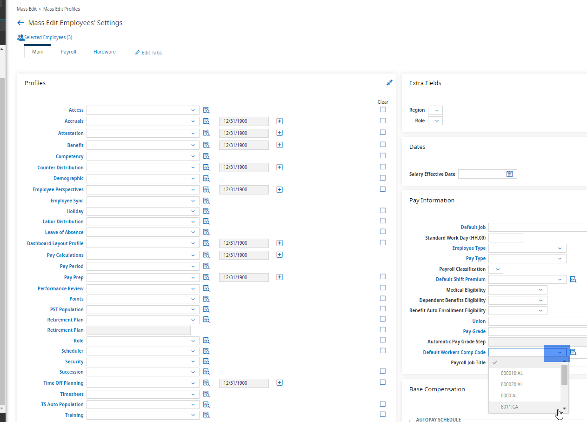

# E-Comp Report Creation

In order to create your E-Comp Report, go to My Info>My Reports>Payroll Reports>Post Payroll Reporting>Workers Comp Code (Summary):

On the top right corner of the page, click on “…” and select Add/Remove Columns:

From there you can select all current columns and then click on remove:

Then, you will search the available and current columns by typing the name of the columns needed into the search bar:

Then, select the column and click on add to move those columns to the current columns report:

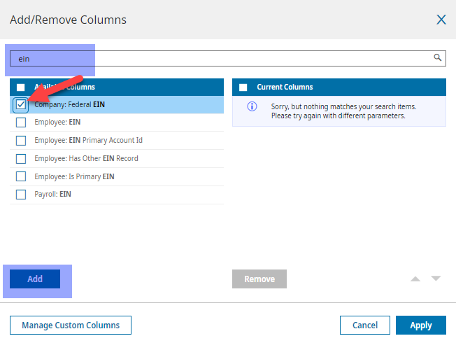

If this is done correctly, you will now see it in the current columns side:

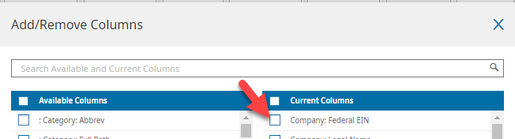

Add the following columns to your report:

* Company: Federal EIN
* Company: Legal Name
* Payroll: Pay Date
* Payroll: Pay Period Start
* Payroll: Pay Period End
* Employee: Employee Id
* Employee: Last Name
* Employee: First Name
* Employee: SS#
* Employee Date: Hired
* Employee Date: Terminated
* Workers Comp: Code
* Workers Comp: State
* Workers Comp: Hours: Workers Comp
* Workers Comp: Gross Earnings
* Custom Column: Excluded Overtime
  + Click on Manage Custom Columns:
    - Change the Label name to Excluded Overtime and click on apply.

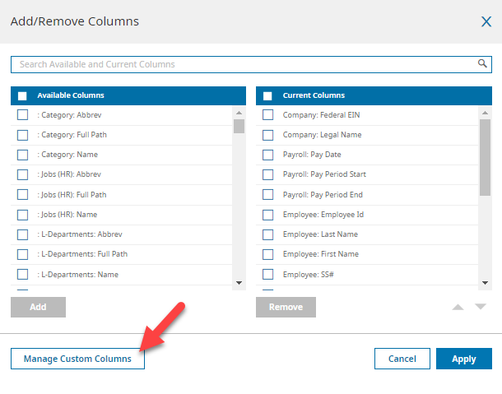

* Workers Comp: Ineligible Wages
* Workers Comp: Tips
  + If you don’t have an available column for Workers Comp: Tips, add in an additional custom column by going back into manage custom columns, then select add another, rename the label to Tips and click apply:



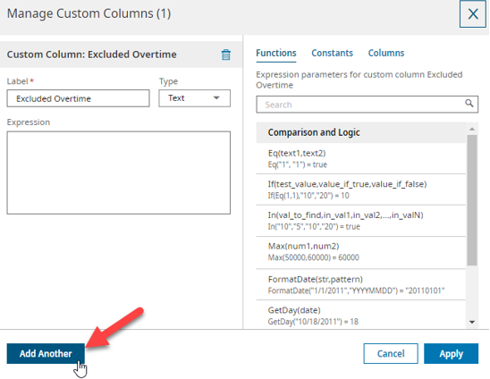

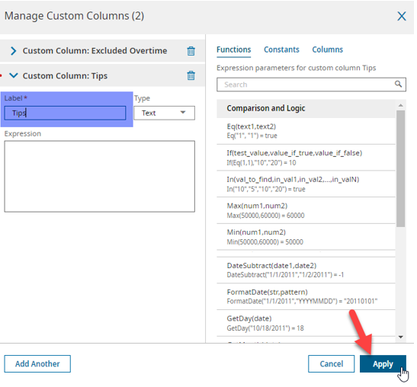

* Workers Comp: Eligible Wages

Now that all needed columns have been added, click on apply:

You will then want to make sure to save your report by clicking on the “…” and going to save view as:

Name the report, click on share so that others that have the correct security access can also view the report and click on Save & Run:

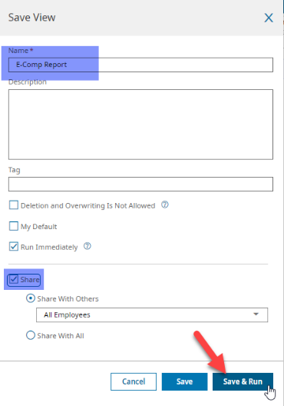

Click on the filter for Pay Dates: Last And Current Months to edit the filter:

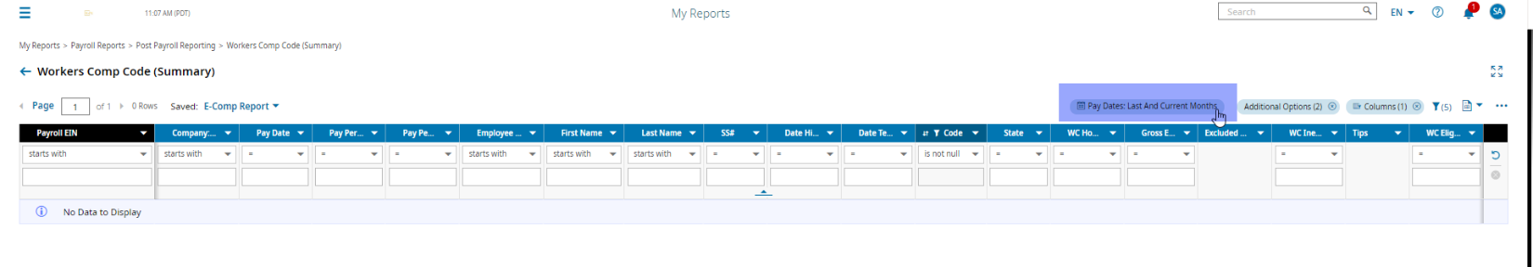

Change the Date Range to This Year and uncheck the Show Only Finalized Payrolls and Show Only Eligible boxes and click apply:

You will want to double check this report to see that is accurately pulling in the Workers Comp hours, Earnings, Ineligible and Eligible Wages, etc.

Once you have ensured that the data is coming through accurately, you will want to rename the columns by going to your “…” and clicking on Export Settings:

Under Advanced Settings, deselect Display Header/Footer and Display Totals and select custom under Export Dash As and put in a zero, then click on Columns To Export:

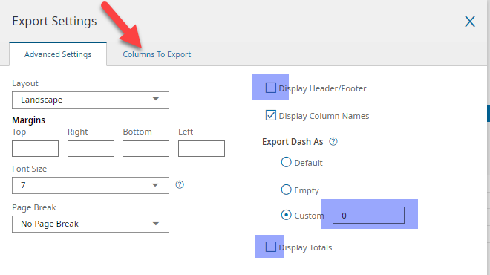

Change the Custom Label to reflect the report columns needed, and click on apply:

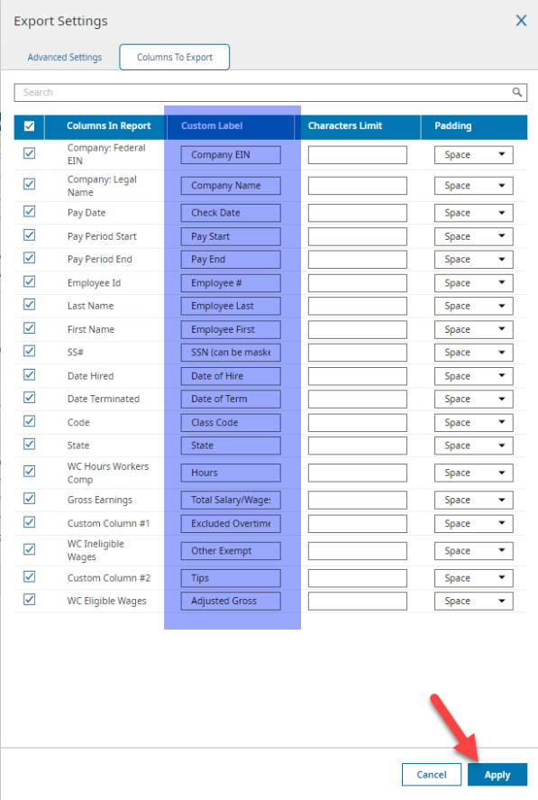

Once this is complete, change the pay date filter again by selecting Pay Date: This Year:

Change the filters to specific payroll, currently being delivered, and select the option to show only finalized payrolls, then click apply:

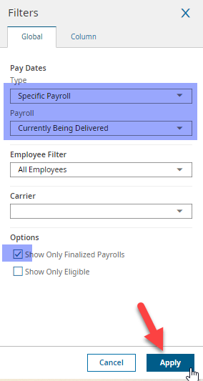

Double check your columns to make sure there aren’t any filters; all columns should be set to “=”, “starts with”, or blank.

Go back to your “…” and click on Save View:

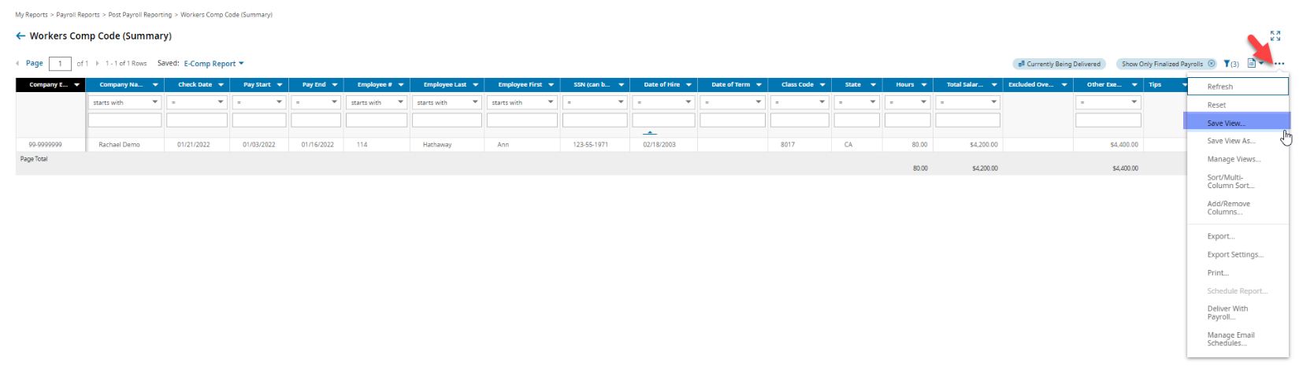

Then click on Save & Run:

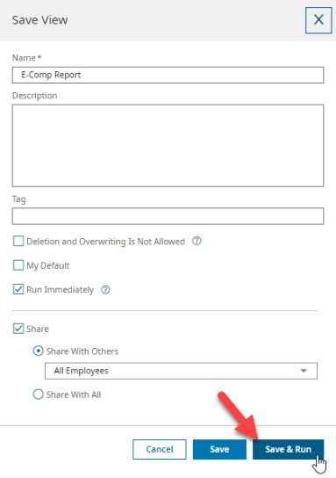

# Adding Delivery Destination for E-Comp Report

It is recommended that prior to setting up your Delivery Destination, you set up a notification email. You can do this at the main administration level under Maintenance>Configuration>Delivery Destinations and clicking on add new delivery destination:

Create a name for your Delivery Destination, select Email as Type and enter an email, from, subject, etc. and click on save.

Next, to create your Delivery Destination for your E-Comp Report, go back into your company and go to Admin>Payroll Setup>Delivery Destinations:

Click on add new delivery destination:

Name your Delivery Destination E-Comp SFTP and select SFTP from the Type dropdown menu:

The highlighted information below will be provided to you by E-Comp and will be unique for the Company, so you will then fill out accordingly and you can set your Failure (E-Mail) that you created in the prior step under Timing of Notifications and then click on save:

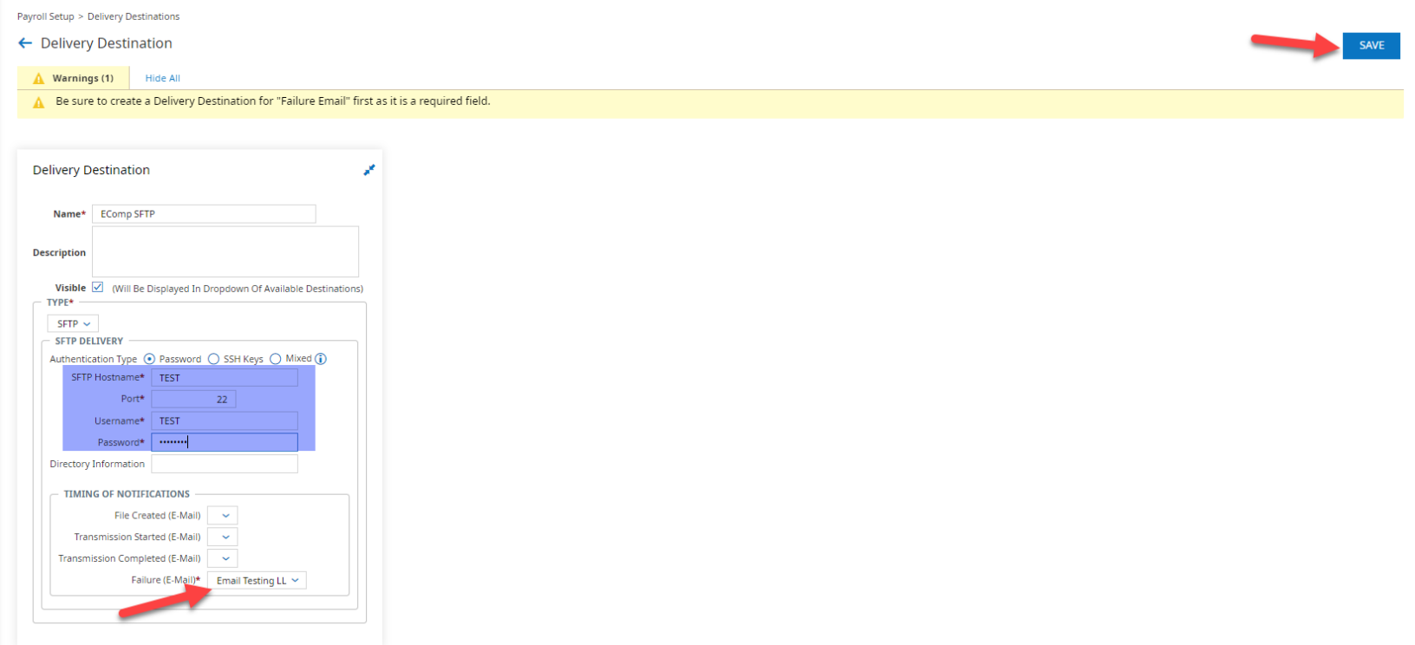

Next, go to Admin>Profiles/Policies>Delivery:

Click on new delivery policy:

Select Reports from the dropdown and click OK:

Name your Delivery Policy and then select the Delivery Destination that you just created from the dropdown and click on save:

Now that the Delivery Policy has been created, you will go back and attach it to the report that you created. Go to Main Menu>My Info>My Reports>My Saved Reports and use the Saved As Name to filter for your report that you created:

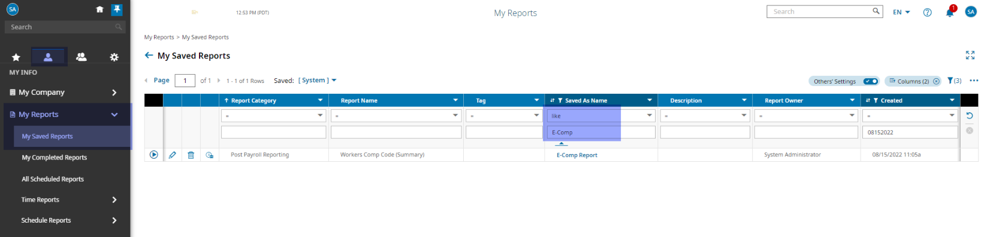

Click on Run Report:

Then click on “…” and select Deliver With Payroll:

Select Enable Deliver With Payroll and choose your Delivery Policy and a Report Format of CSV, then click on Save:

